*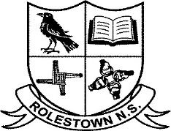Rolestown National School*

Rolestown, Telephone: 01-8404130

Co.Dublin. E-mail:office@rolestownns.ie

Roll Number 17820J

RCN. 20205441 www.rolestownns.ie

**Board of Management Meeting 10th June ’24.**

**Agreed Report:**

1. Child Safeguarding Statement and Risk Assessment reviewed and updated.
2. Annual Child Protection review checklist completed.
3. 3 New policies to be ratified by Board of Management at next meeting; Attendance Policy, SNA Policy and Assessment Policy.
4. Well done to whole the school community on the recent Fingal Ravens 5k Fun Run, the Fingal Ravens Oskars Fundraiser and all our boys and girls who took part in the Rolestown NS School Marathon recently. Vital funds have been raised for our school. We are extremely grateful to everyone who both participated and contributed funds.